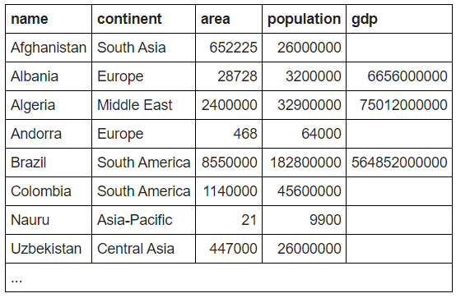



**SELECT name FROM world WHERE name LIKE 'U%'**



**SELECT population FROM world WHERE name = 'United Kingdom'**



**SELECT** continent

**FROM** world

**WHERE** 'name' = 'France'

**'name' should be name**



**SELECT** name, population / 10

**FROM** world

**WHERE** population < 10000

|  |  |
| --- | --- |
| Nauru | 990 |



**SELECT name, population FROM world WHERE continent IN ('Europe', 'Asia')**



**SELECT name FROM world WHERE name IN ('Cuba', 'Togo')**



**SELECT** name **FROM** world

**WHERE** continent = 'South America'

**AND** population > 40000000

|  |
| --- |
| Brazil |
| Colombia |